CSA1708-ARTIFICIAL INTELLIGENCE
LAB EXPERIMENTS
Program 4: Python program for Cript Arithmetic Algorithm
Aim:
To solve a cryptarithmetic puzzle by assigning unique digits to letters.
Algorithm:
- Assign different digits to each letter.
- Ensure the first letters are not zero.
- Convert the words into numbers.
- Check whether SEND + MORE = MONEY.
- Print the solution when the equation is satisfied.
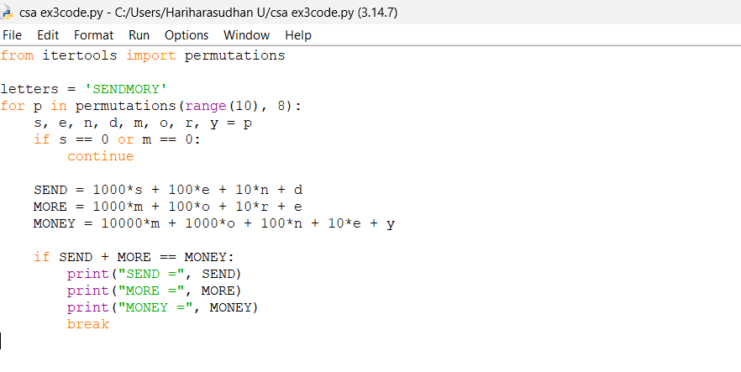
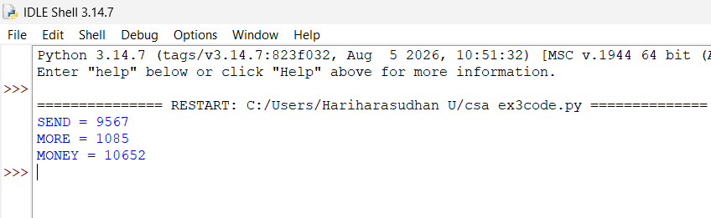
Result: Thus, the crypt arithmetic problem was successfully solved using Python.

